1. Angular is a [JavaScript](https://www.simplilearn.com/tutorials/javascript-tutorial/introduction-to-javascript) framework for building single-page client applications using [HTML](https://www.simplilearn.com/tutorials/html-tutorial/what-is-html) and TypeScript. It is primarily written in TypeScript and implements core functionality as a set of TypeScript libraries that you import into your apps.
2. NodeJS:

Angular uses Node.js for a large part of its build environment. As a result, to get started with Angular, you will need to have Node.js installed on your system. You can head to the NodeJS official website to download the software. Install the latest version and confirm them on you command prompt by running the following commands:

node--version

npm--v

### 3.Angular CLI :

The Angular team has created a command-line interface (CLI) tool to make it easier to bootstrap and develop your Angular applications. To install the CLI, in the command prompt, type the following commands

Installation: **npm install -g @angular/cli**

Confirmation - **ng—version**

### ****4.**** Text Editor

You need a text editor to write and run your code. The most popularly used integrated development environment (IDE) is Visual Studio Code (VS Code). It is a powerful source code editor that is available on Windows, macOS, and Linux platforms.

5. At its core, any Angular application is still a Single-Page Application (SPA), and thus its loading is triggered by a main request to the server. When we open any URL in our browser, the very first request is made to our server. This initial request is satisfied by an HTML page, which then loads the necessary JavaScript files to load both Angular as well as our application code and templates.

## 6. **What Are Angular Components?**

Components are the building blocks of a UI in an Angular application. These components are associated with a template and are a subset of directives.

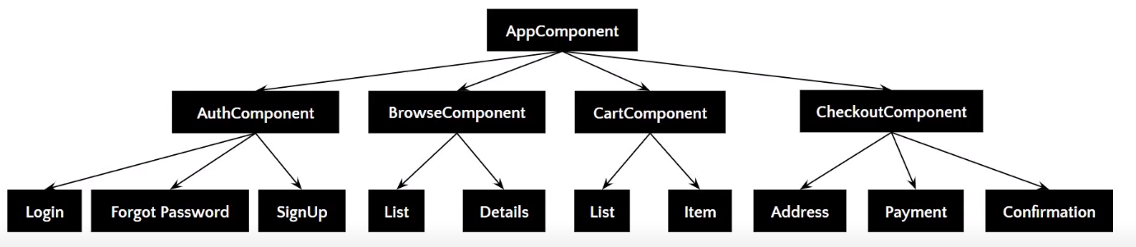

The above image gives the tree structure of classification. There’s a root component, which is the AppComponent, that then branches out into other components creating a hierarchy.

* Components are typically custom [HTML](https://www.simplilearn.com/tutorials/html-tutorial/what-is-html) elements, and each of these elements can instantiate only one component.
* A TypeScript class is used to create a component. This class is then decorated with the “@Component” decorator.
* The decorator accepts a metadata object that gives information about the component.
* A component must belong to the NgModule in order for it to be usable by another component or application.
* Components control their runtime behavior by implementing Life-Cycle hooks.
* in the index.html file, <app-root> tag corresponds to component’s selector. By doing so, Angular will inject the corresponding template of the component.
* 